CS105-Spring 2020 / B55

Bartenstein, Tom

Word 1-2

Spring Break
Trips on a Budget
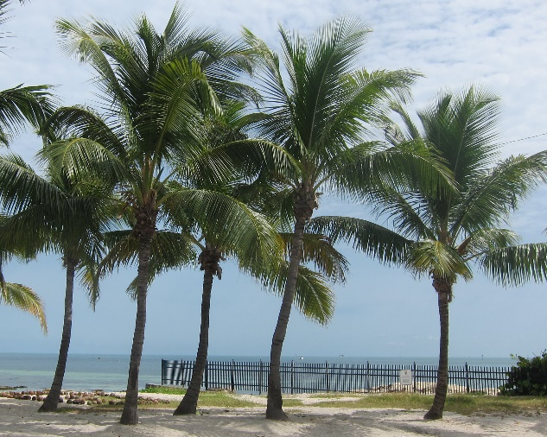
Bartenstein Travel
578 Park Street in Jonner
- Packages include airfare, rental car, accommodations and dining
- Discounted attraction tickets
- Destinations around the country
- Fund-raising tools for you to use on Facebook, Twitter, or via email
Call us at 605-555-6000 or stop by today

